



Power BI Desktop


OTT Hotstar Netflix Amazon

1928
2023
V
All
V
All







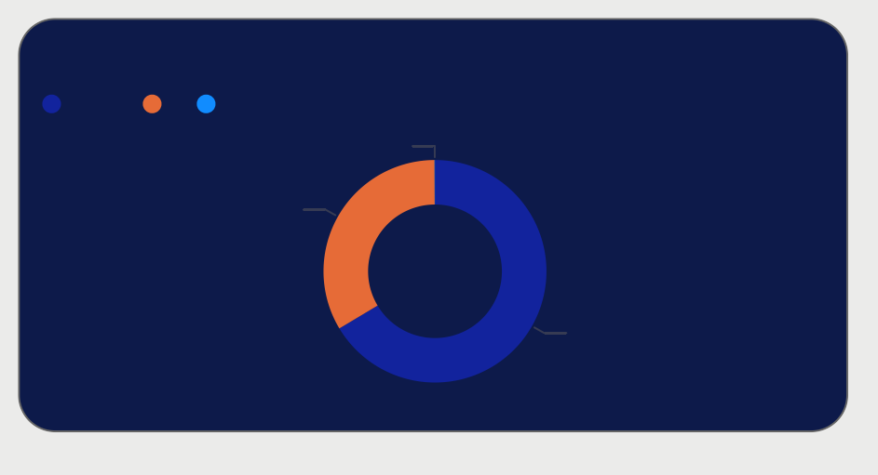
Total Movies/Shows by Released Year

500
Count of title

0
1950 2000

year

type movie tv

U/A 13+
U U/A 16+
U/A 7+
Rating by Total Shows

movie tv
Count of Movies And Tv Shows

0K

2.31K

4.57K

0 500 1,000 1,500 2,000
Power BI Desktop
Count of title




Power BI Desktop
genre
Total Shows by genres
type
movie tv
10%

5%
6877
0%
Drama Comedy Romance
Action Reality Thriller Family Animat… Docum…
Sport Animal… Horror Kids Crime Mythol… Talk Sh… Superh…
Standu…
OTT Hotstar Netflix Amazon
Tv shows
4445
Tv shows
2306
Genres
38
Types of data
3

 | 1928 |  | 2023 |  | All V |  | All V |           genre

500
Count of title
Total Movies/Shows by Released Year
Tv shows

4445
Tv shows

2306

0
1950 2000
6877
Genres

38
Types of data

3

year

type movie tv U/A 13+
Rating by Total Shows
Count of Movies And Tv Shows

movie tv
0K
Total Shows by genres
type movie tv

10%








U U/A 16+
Power BI Desktop
OTT Hotstar Netflix Amazon
U/A 7+

0 500 1,000 1,500 2,000
Count of title
2.31K

5%
0%
Drama Com… Rom… Action Reality Thriller Family Anim… Docu… Sport Anim… Horror Kids Crime Myth…
Talk …
4.57K





Count of movies and Tv shows
Ratings
0
5329
5332
TV-G
84
OTT Hotstar Netflix Amazon
Rating Type Show Type
Power BI Desktop
V
All
V
All



Total Cast
25.45K

Total Director
4295

TV-MA | 1821
TV-14 | 1213
R | 777
PG-13 | 470
TV-PG | 431
PG | 275

OTT Hotstar Netflix Amazon

Genre Type
Power BI Desktop
All V





Year

Total Country
109

Total Genre
42
All V










Country
Yearly Release
Type Movie TV Show
©© 22002244 MMiiccrroossoofftt CCoorrppoorraattiioonn
1990
1995
2000
2005
2010
2015
2020

Rating Type
Power BI Desktop
Show Type
Genre Type
Year

 | All V |  | All V |  | All V |  | All V








Total Genre
OTT Hotstar Netflix Amazon

42
Total Cast

25.45K
Total Director

4295
Total Country

109
Count of movies and Tv shows

5329
0 5332

TV-MA TV-14
R PG-13 TV-PG
PG
Ratings
1821
1213
777
470
431
275

Country

Type Movie TV Show
Yearly Release

© 2024 Miiccrrossofftt Corrporrattiion
1990 1995 2000 2005 2010 2015 2020

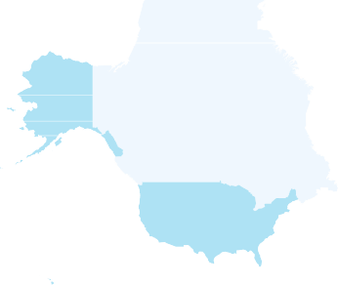
Power BI Desktop
Ratings by total shows
13+
R 16+ ALL
PG-13 18+
PG
170
97
71
56
56
44
18
0
50
100
Count of show_id
150
Genres by total shows
listed_in
rating
Drama Comedy Come… Drama… Drama… Drama… Come… Docu… Docu… Suspe… Action,… Action,… Horror… Action,… Come… Action Interna… Action,… Action,… Roman… Action,… Come… Drama… Horror
Interna…
Total shows by country
Total Genres
Total Ratings
130
538
OTT Hotstar Netflix Amazon



Power BI Desktop
Total Titles
538
Total Directors
454
2021
1939
OTT Hotstar Netflix Amazon

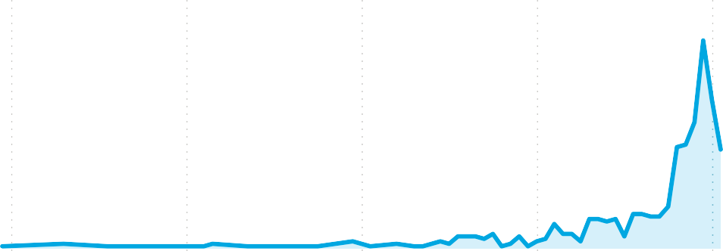
Movies and TV shows
type
Movie
538 (100%)
Total shows by release year
type Movie
100
50
0
1940
1960
1980
2000
2020



Power BI Desktop
170
0
100
Count of show_id
listed_in
Total Titles
538
Total Directors
454
Total Genres
130
Total Ratings
538
rating
Drama Comedy Come… Drama… Drama… Drama… Come… Docu… Docu… Suspe… Action… Action… Horror… Action… Come… Action Intern…
Action…
OTT Hotstar Netflix Amazon

Ratings by total shows | 1939 |  | 2021 | Genres by total shows

13+
R |  |  |  |  |  | 97
16+ |  |  |  |  | 71
ALL |  |  |  | 56
PG-13 |  |  |  | 56
18+ |  |  | 44
PG |  | 18







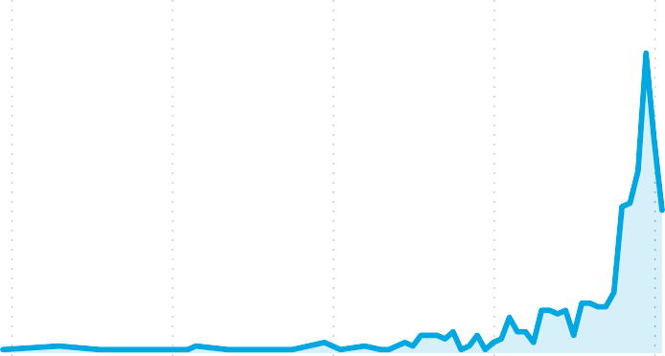
Total shows by country
©© 22002244 MMiiccrroossoofftt CCoorrppoorraattiioonn
Movies and TV shows
type
Movie
538 (100%)
Total shows by release year
type Movie
100
50
0
1940
1960
1980
2000
2020

